5G/6G Communication Systems- ECA5601 (LAB)
Student Name: A.SAI KIRAN
Reg no: 192312672L

Experiment 4: OFDMA Resource Block Allocation
Aim: To simulate and analyze OFDMA (Orthogonal Frequency Division Multiple Access)
resource block allocation and evaluate system performance in terms of resource utilization and user throughput using MATLAB.
Objective
1. To determine the Number of Resource Blocks (RBs) allocated in an OFDMA system
based on available bandwidth and system configuration.
2.To evaluate the Resource Block Utilization (%) by analyzing how efficiently available
RBs are assigned to active users.
3.To calculate the User Throughput (Mbps) based on allocated resource blocks and
modulation efficiency in the OFDMA system.
Procedure
1. Define the system bandwidth and calculate the number of available resource blocks
(RBs) based on RB size (e.g., 180 kHz per RB).
2. Identify the number of active users in the OFDMA system for resource sharing.
3. Allocate resource blocks to each user based on a predefined or equal distribution
strategy.
4. Compute Resource Block Utilization (%) using the ratio of allocated RBs to total RBs.
5. Assign modulation efficiency values (e.g., QPSK, 16-QAM, 64-QAM) for each user.
6. Calculate User Throughput (Mbps) using allocated RBs and modulation efficiency.
7. Plot graphs for RB allocation and utilization/throughput analysis using MATLAB.
8. Analyze results to evaluate spectrum efficiency and system performance.
Objective 1:
clc; clear; close all; % System parameters bandwidth = 10e6; % 10 MHz rb_size = 180e3; % 180 kHz per RB
% Total Resource Blocks total_RB = floor(bandwidth / rb_size);
% Users users = 1:6;
% RB allocation (simple equal + remainder distribution) base = floor(total_RB / length(users));

alloc = base * ones(1,length(users)); alloc(1:mod(total_RB,length(users))) = alloc(1:mod(total_RB,length(users))) + 1; utilization = (alloc / total_RB) * 100; disp('Total Resource Blocks:') disp(total_RB) disp('RB Allocation per User:') disp(alloc) figure
% -------- Graph 1: RB Allocation per User --------
subplot(2,1,1) stem(users, alloc, 'filled', 'LineWidth', 2) title('OFDMA Resource Block Allocation per User') xlabel('User Index') ylabel('Number of Resource Blocks') grid on
% -------- Graph 2: RB Utilization -------- subplot(2,1,2) plot(users, utilization, '-o', 'LineWidth', 2) title('OFDMA Resource Block Utilization (%)') xlabel('User Index') ylabel('Utilization (%)') grid on
Output:
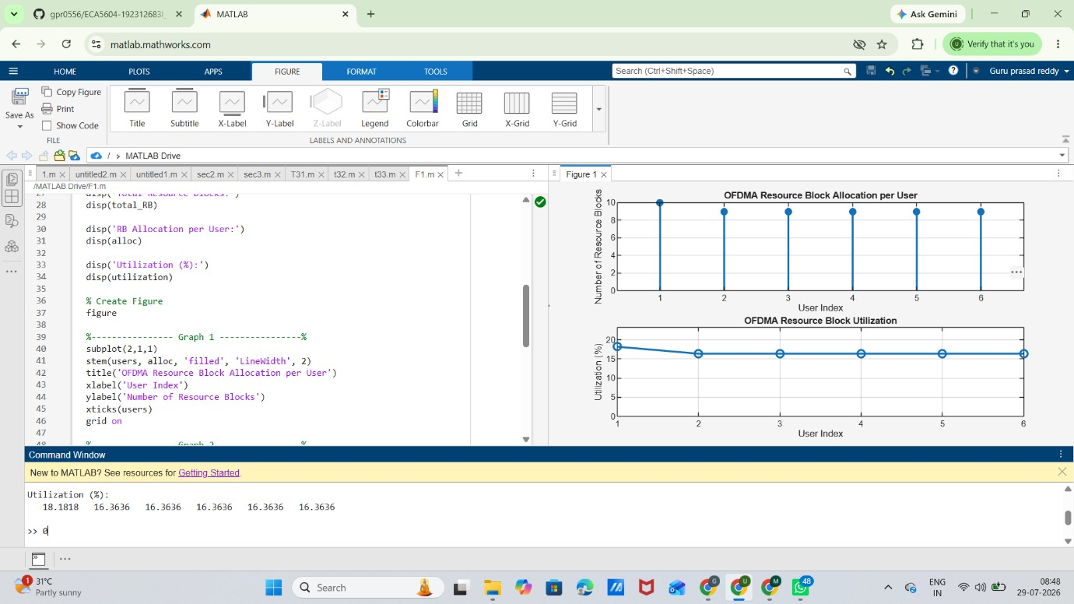

Objective 2:
MATLAB Code:
clc; clear; close all;
% Total system resource blocks total_RB = 50; % Number of active users users = 1:5;
% RB allocation to users (example scenario) alloc = [12 10 9 8 11]; % Resource Block Utilization (%) util = (alloc / total_RB) * 100; disp('Resource Block Utilization (%) per User:') disp(util') figure
% -------- Graph 1: RB Allocation -------- subplot(2,1,1) plot(users, alloc, '-o', 'LineWidth', 2) title('OFDMA Resource Block Allocation per User') xlabel('User Index') ylabel('Number of Resource Blocks') grid on
% -------- Graph 2: Utilization (%) -------- subplot(2,1,2) plot(users, util, '-s', 'LineWidth', 2) title('OFDMA Resource Block Utilization (%)') xlabel('User Index') ylabel('Utilization (%)') grid on

Output:
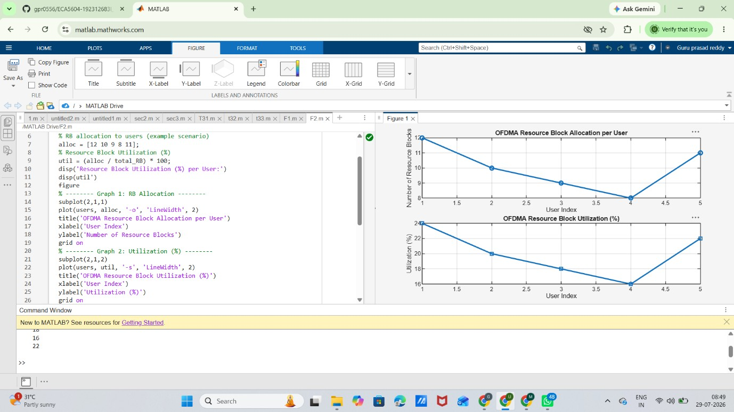
Objective 3:
MATLAB Code:
clc; clear; close all; % System parameters rb_bw = 180e3; % Bandwidth per RB (180 kHz) users = 1:5;
% Allocated Resource Blocks per user alloc_RB = [12 10 9 8 11];
% Modulation efficiency (bits/symbol) mod_eff = [2 4 6 4 2]; % QPSK, 16QAM, 64QAM etc.
% Throughput calculation (Mbps) throughput = (alloc_RB .* rb_bw .* mod_eff) / 1e6; disp('User Throughput (Mbps):') disp(throughput') figure
% -------- Graph 1: Throughput per User -------- subplot(2,1,1)
plot(users, throughput, '-o', 'LineWidth', 2) title('OFDMA User Throughput') xlabel('User Index') ylabel('Throughput (Mbps)') grid on
% -------- Graph 2: RB vs Throughput -------- subplot(2,1,2) plot(alloc_RB, throughput, '-s', 'LineWidth', 2) title('Resource Blocks vs Throughput Relationship') xlabel('Allocated Resource Blocks') ylabel('Throughput (Mbps)') grid on
Output:
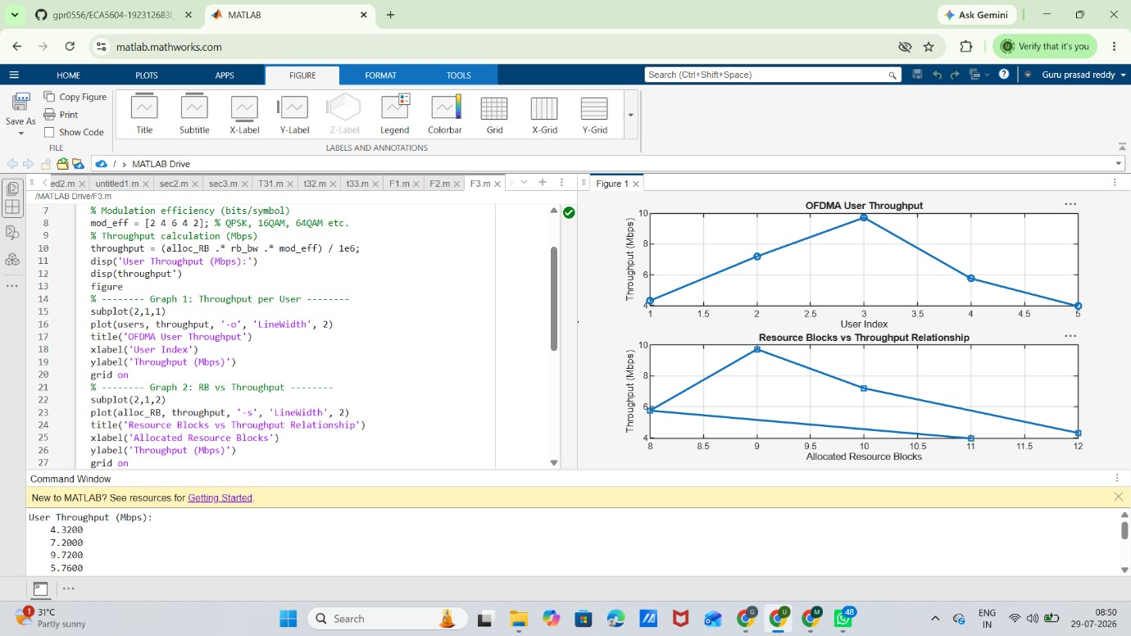
Result:The propagation loss for Sub-1 GHz, Mid-band, and mm Wave frequency bands was successfully analysed using MATLAB. The results showed that propagation loss increases with both frequency and communication distance, with mm Wave experiencing the highest attenuation and Sub-1 GHz providing the best coverage.

